5.20: Similar to Exercise 5.16, the angle is 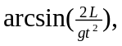, but here the time is found in terms of velocity along the table, 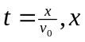 being the length of the table and  the velocity component along the table. Then,
